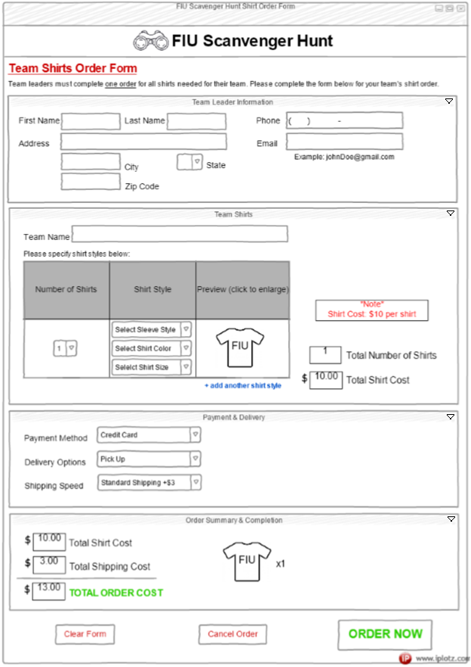Initial Design:

Initial Design Description:

The original order form was designed to be a series of four (4) accordion sections. Unfortunately, when selecting Accordion from the Components items, only one section would be visible at once. Although this would not be terrible for the webpage’s design, I would have liked to have the option of having more than one section visible at once so for the sake of this mockup design, I made each section into a Panel instead. I would have liked for there to be a small arrow at the top right corner for each section. Since neither their Accordion or Panel Components had this, I made my own small arrows using MS Paint. I would have also liked it if each of the Accordion section titles could have been larger so they would be more visible to the user, but there was no option to resize these titles on the iPlotz website. The first section is for The Team leader’s Information, the second section is for the specifications of the Team Shirts, the third sections is for the Payment & Delivery Information and the last section is to display the order summary and provide a visual for the customer to view their order.

Team Leader Information section:

This section is very standard. It contains text boxes for entering first/last names, address, city, zip code and email. The state is chosen via dropdown box and the box for phone number will have a predetermined format specific for entering 10-digit phone numbers.

Team Shirts section:

After entering the team name in the text box at the top of this section, it will be used in the preview box shown. All specifications for the shirt including the type of sleeves, the shirt color and the shirt size must be selected from the dropdown lists before a preview appears in the preview box. The user may click on the thumbnail to see a larger image of the shirt with their selected specifications shown along with “FIU” and their team name underneath. If they would like multiple shirts with the same specifications, they indicate how many of these shirts they would like using the dropdown list in the Number of Shirts column. There is a clickable message stating +add another shirt style if the user would like to have their team shirts appear in different sizes, colors or sleeve styles, but still displaying the same team name. Clicking this will add another row to the chart and allow the user to choose the new shirt specifications.

I would have liked for the items in the Shirt Style column to be displayed next to each other instead of vertically on top of each other, but I couldn’t figure out how to get iPlotz to arrange this display.

On the right side of this section, there is a box with red text informing the user of the cost per shirt. It was made red for extra visibility so the user is aware of how their costs will be changing as they make their choices. The two boxes near the bottom are updated as the user fills out the chart with their desired shirts and specifications. The Total Number of Shirts will update depending on the numbers chosen from the dropdown list(s) in the Number of Shirts column. The Total Shirt Cost will also update depending on the Total Number of Shirts selected. This is important visible feedback given to the user to confirm that their choices are being acknowledged by the form.

Payment & Delivery section:

This section is where the user will choose these options. It is also where they will see the cost of shipping.

Order Summary & Completion:

This section will reflect the choices made by the user in the Team Shirts section and in the Payment & Delivery section and show the Total Oder Cost with big green letters on the left side to add visibility to the final cost to the user. In case the user does not remember some of their choices, the pricing calculation is also display.In addition to this, on the right side of this section, the thumbnail images representing all the user’s shirt choices will appear along with a x1, x2, x3 (for example) which would represent how many of that style shirt is included in the order. These thumbnail images will be the same thumbnails that are shown in the preview column of the chart within the Team Shirts section.

Upon completion of the user’s choices and reviewing the order, three buttons are displayed at the bottom of the screen. The Clear and Cancel buttons are smaller and shown with red text to ensure the user understands that they are “stopping” their order from progressing. The final submitting ORDER NOW button is larger and shown in green to draw the user’s attention and signify a “go on” to complete the order as is.

User Feedback

Feedback from User #1:

* Easy to use
* Nicely organized
* Simple
* Needs more specific visible options for the payment section. (ie: showing the fields for the credit card information when “Credit Card” is selected as the payment method, specifying if the delivery address would be to the same address as the previously entered customer information or if it should be delivered to a different address.)

Feedback from User #2:

* Liked button color/size choices at the bottom
* Liked the updating preview in the Team Shirts and Order Summary & Completion sections.
* Liked that the total number of shirts and total shirt cost were displayed for the user in both Team Shirts and Order Summary & Completion sections as good feedback.
* Did not like the red title “Team Shirts Order Form” because it looked too much like an advertisement
* Needed to add a second line for address or an apt field in the Team Leader Information section

(view updated design on next page)

Updated Design:

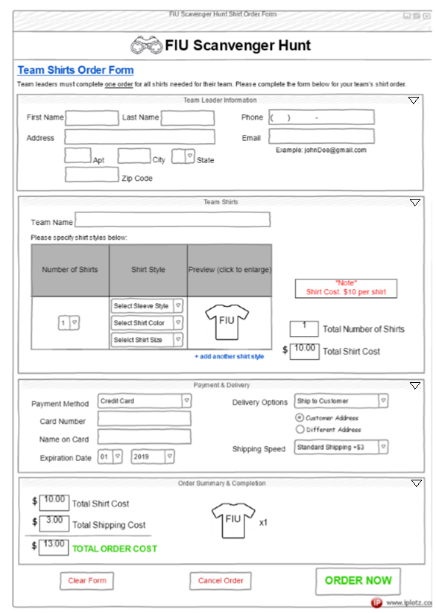

Design Changes:

* “Team Shirts Order Form” Title at the top was changed to a blue color so it does not look like an advertisement anymore.
* An “Apt” field was added to the Address information part of the Team Leader Information section for utility
* In Payment & Delivery section, Payment information will be collected on the left side of this section and Delivery information will be collected on the right side of the section.
* In Payment & Delivery section, when Credit Card is selected as the payment method, the text boxes for Card Number, Name on Card and Expiration Date appear below it.
* In Payment & Delivery section, the option to ship to a different address is displayed as a radio button under Delivery Options. If the Delivery Option is set to Pick Up by the user, these radio buttons will be disabled.

URL to my Axure Prototype:

<https://kdb2kk.axshare.com>

(Unfortunately, I was unable to make every feature work within the time limits of this assignment, but you can still get the idea of where I was going with it.)